
Progress update


Dear colleagues, as indicated in the last newsletter we want to keep you informed of the progress of FlowerPower. Progress will be shown through the coloring of the Flower as we move forward with more projects reaching a stage where all efforts to achieve the 2023 impact have been completed (so-called L4 approved) and of course through the project specific articles. The more projects reach L4, the more colourful our flower will become.
Since last newsletter 2 projects were approved to move to L4 (#164 and 140) and another 6 projects have been submitted for approval. A lot of great work is being done by all the project teams and we expect quite a few projects to be submitted for L4 approval (and hopefully to be approved) in the weeks to come, so stay tuned!
Jasper de Gou, TO Project Manager

Flower Power achievements around the world

Finance (Project 164)
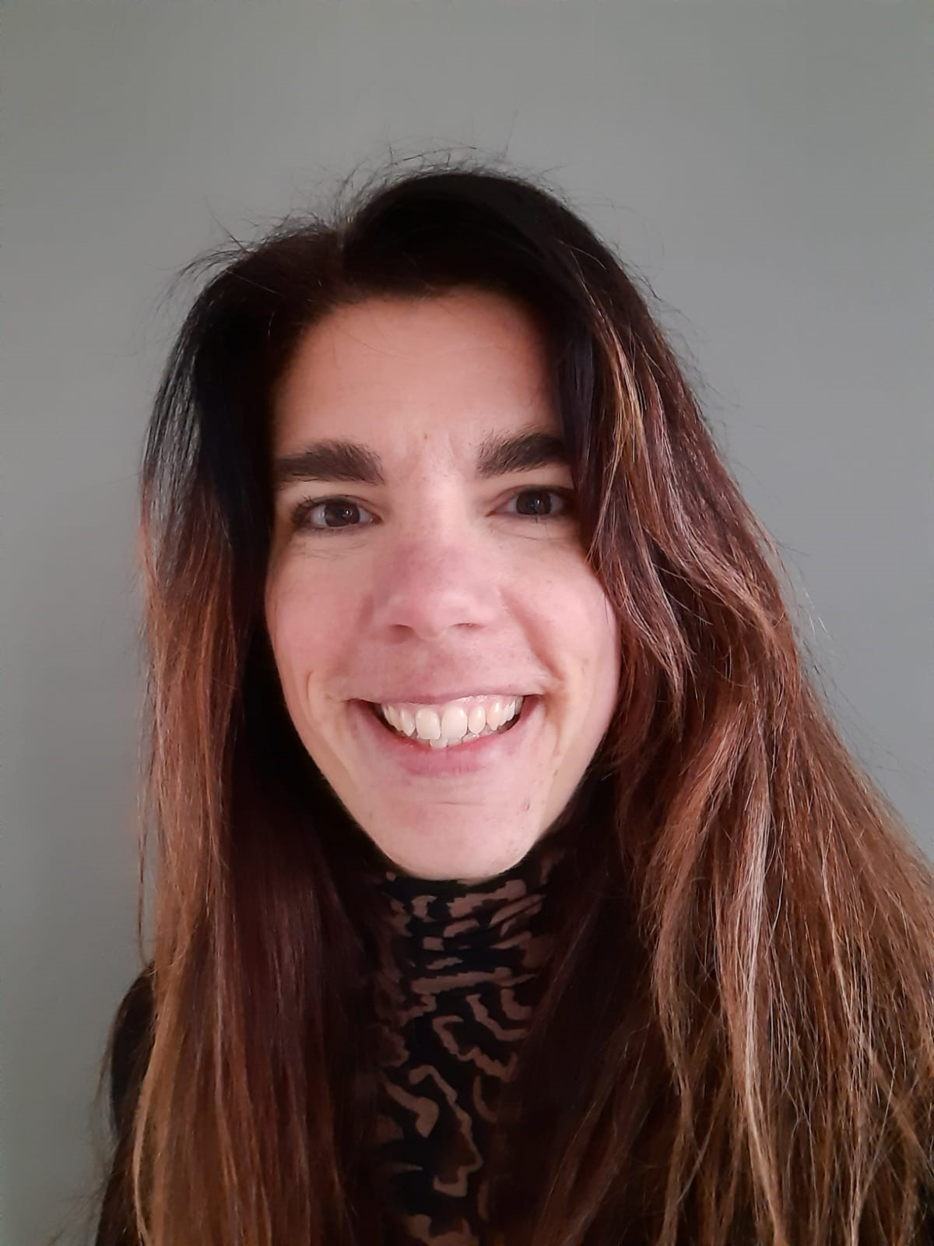
Our Finance team is involved in a number of FlowerPower projects. Project 164 is intended to provide a clear schedule of the finance activities year-round. Each year we have recurring activities that have to be completed by the various Finance teams around the globe. Examples are: budget process, definition of transfer prices, annual financial statements and the monthly financial close.

As Group Control we are in the lead to plan and manage these activities. We had noticed that there was a need from the overall Finance community to have better insight on the predefined tasks for the year. This way the team could be better equiped to plan and execute the activities. So, we have conducted an inventory and prepared a clear overview of year-round finance activities.
Jeannette Groenewegen, Group Controller

During the creation of the calendar Group control and Business Control have been teaming up to have a good understanding of the timing involved for each activity. Next, the activities have been plotted on a timeline. This provided a clear overview on timing, but also on potential conflicts. The conflict situations have been adjusted to ensure a minimization in overlap of activities
The Finance calendar has been rolled out to all Finance colleagues and positive feedback has been received. They appreciate the clarity this calendar provides for them. This calendar can also give clarity to colleagues beyond finance as to when the finance community is busy with recurring tasks and therefore responding to a query in these busy days may take more time. With the implementation the project has reached L4. We are looking forward to also bring our other Finance projects to L4!


Uganda Energy Saving (Project 200)
In November 2020 we initiated the roll out of flower power project #200 whereby the first phase is to look at how we can save energy without investment. Fiduga is committed to responsible energy utilisation and ensures efficient energy consumption in all operational areas (lighting, equipment, water, machinery and transportation), educating our staff on sustainable and environmentally friendly energy usage without compromising on quality standards and client satisfaction. Employees who have shown exemplary strides and stand out among their peers in creativity, innovativeness, dedication and actions towards energy conservation at the farm are recognized and appreciated. The recognition is aimed at motivating behavioural change and to increase employee contribution to the implementation of energy saving.
Yaeger Adlam, Managing Director Uganda

Some actions include:
- Switching off lights in discarded/empty greenhouses - electricians focus on such areas and keep the lights off hence saving energy.
- In rooms that are unoccupied for more than 15 minutes, lights, computers, printers are turned off.
- Planning delivery/collection of procurement items effectively as to save fuel.
- Re-organizing specific routes for the collection of our cuttings from the greenhouses to the cold-room on the farm.

All employees received the implementation of this project very well and at first it was hectic to switch off/on, forgetting etc. but now everyone is really used to it and have come up with many creative ideas how we can further save which is highly appreciated and supported by Management.

Last month Mr. LEOPOLD TUSIIME our R&D Manager was recognized and appreciated for being Simply the Best, making a saving of 1044.9 KWH per month (small actions lead to greater impact). This month the team of tricycle operators, responsible for the collection of harvested cuttings from the greenhouses and delivery to the cold-room were awarded due to behaviour change which led to a great saving on fuel. Each month the energy saving team lead by Barbara Najjuma (Technical Department) awards a branded cap to the energy star for exceptional efforts. Fair to say that flower power project #200 is no longer seen as merely a project but as a new way of life at Fiduga where everyone feels responsible for the improvements.


Cut Flowers (Project 133)
The majority of the rose market is concentrated in Africa and from a commercial perspective it is very interesting to introduce new varieties here. Project 133 is intended to reach a higher market share with the introduction of two new varietes in the yellow and red segment. Together with the team we have defined an implementation plan on how to position these varieties, with the appropriate growers and a plan for the coming years.
Niels Pennings, Sales Manager Rose EU

Our customer Holla Roses is currently propagating 3 acres of the breed Red Tacazzi+. Together with our marketing team and the grower, we are working on a great introduction. We targeted to sell 1-2 acres during the first year, but already we are able to sell more. We have high expectations and are looking forward to see how the market is going to embrace this variety. Next year we anticipate to sell 3-5 acres of Red Tacazzi+ which establishes a strong growth.

Within the yellow segment, we have a new rose: Momentum+. This breed will be introduced this year in Africa and South America. Also for this introduction we have a solid plan for a successful launch. Our prognosis was to sell 1-2 acres this year, however we now expect to sell 3.25 acres. We are working hard with the team to stimulate a strong growth.

The total royalty value during the first year is expected to be €250-350k. Depending on how the market will embrace the two varieties, we anticipate that the value will double during the second year.
Thanks to everyone who is helping to turn project 133 into a great success!
A2E Workshops Olij & RedFox Ethopia, DO Delta & Global
To support our FlowerPower initiatives, but also the value drivers of our company, we have started with a program called Ability to Execute (A2). This program is build up from 15 different modules and is intended to help all of us to become better at execution of activities and therefor achieving better and timely results.

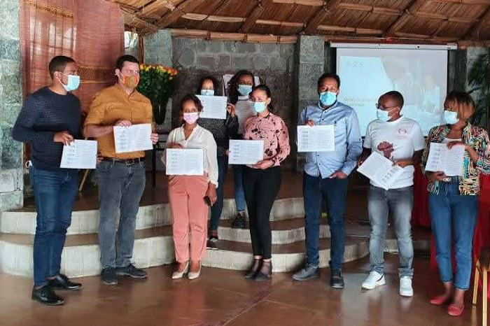
Last year October we have trained an group of early adopters of A2E. From this group a number of employees have volunteered to become a facilitator to support the further roll-out of A2E within their function, Business Unit or region.

In February, Benjamin Goepferich and Bart Engels have started the roll-out of A2E in Africa. The Olij Ethoopia management team is the first group to participate. Early March, the management team of Red Fox Ethiopia has completed the full workshop as well. Going forward, the other farm management teams will be trained, whereafter A2E will be further rolled out to our African colleagues.

That same week, another A2E workshop took place through ZOOM with 50 employees from around the globe. This session was led by RTS (Sam Hodgkinson, Sammy Ta) in conjunction with our own Dümmen Orange facilitators (Freek Tromp, Bas Pellenaars, Caspar Boers, Ricardo Coevoets, Maik Epping, Ellen Lakeman).
This global capability buildig initiative has also kicked off in the US with the training of the Dümmen Orange Delta team by Jennifer Pelsor.

All workshops have received very positive feedback. We are pleased that 11 employees who have taken the workshop, have volunteered as facilitators in the further roll-out to the organization. This brings the group of global facilitators at 26. At this point in time we have already trained >100 employees and we aim to reach 300 employees by the end of September. The more employees that speak the same A2E language and practice the same tools, the more results we can achieve as an organisation.

Are you interested to participate in an upcoming A2E workshop? Please visit the FlowerPower website and find out who the facilitators are for your function, Business Unit or region, or you can reach out to Ellen Lakeman.

