
New format

Starting 2021, we are proud that we already have 7 projects in a stage that all efforts to achieve full 2023 benefits have been completed (so-called L4 stage). Also we have 3 projects that have already realised ~80% of the forecasted benefits (so-called L5).
Going forward we are going to dedicate each FlowerPower Newsletter to these projects and the achievements that have been reached.

Our flower will show our progress and will become more colourful with the increasing project achievements. We also like to recognize the achievements within the OHI action plans and are excited to inform you that the action plan for Dümmen Orange Delta has been fully completed.

Flower Power achievements around the world


IT APPLICATIONS
Over the past years, the so called “Dümmen Orange application landscape” has grown by adding applications due to Mergers & Acquisitions. The landscape consists of a large number of applications. These are used to support different departments, business units and supply chains all over the world.
Rik Juffermans
IM Manager
Rik Juffermans
IM Manager

As IT department we are continuously working to improve the application landscape and to reduce complexity and costs where possible. With these actions we keep our systems fit for purpose and future proof.

Within the IT workstream the recent FlowerPower projects supported us to stop using an application called “Global Planning System (GPS)”. This application was used for managing CutChrysantemum orders and was introduced in 2016. In the meantime the functionality of our PAT application has been enriched. Within this FlowerPower project, together with the Sales team and the Customer Service back office, we managed to eliminate this GPS application and replace it completely by Pat.

The business benefits, besides reducing complexity, are: one system less to support, one system less in hosting and maintenance fee, some interface less between the systems, one system less in user experience and user education.

You can image that such a large number of applications also require a large amount of yearly maintenance fees. Within two other Flower Power projects, we managed to stop the maintenance contract for an application not being on the critical path anymore and negotiated with another supplier to reduce cost. Both projects helped in reducing costs for Dümmen Orange for the coming years.


ETHIOPIA
Yordanos Jemal Shkuri
General Manager Koka
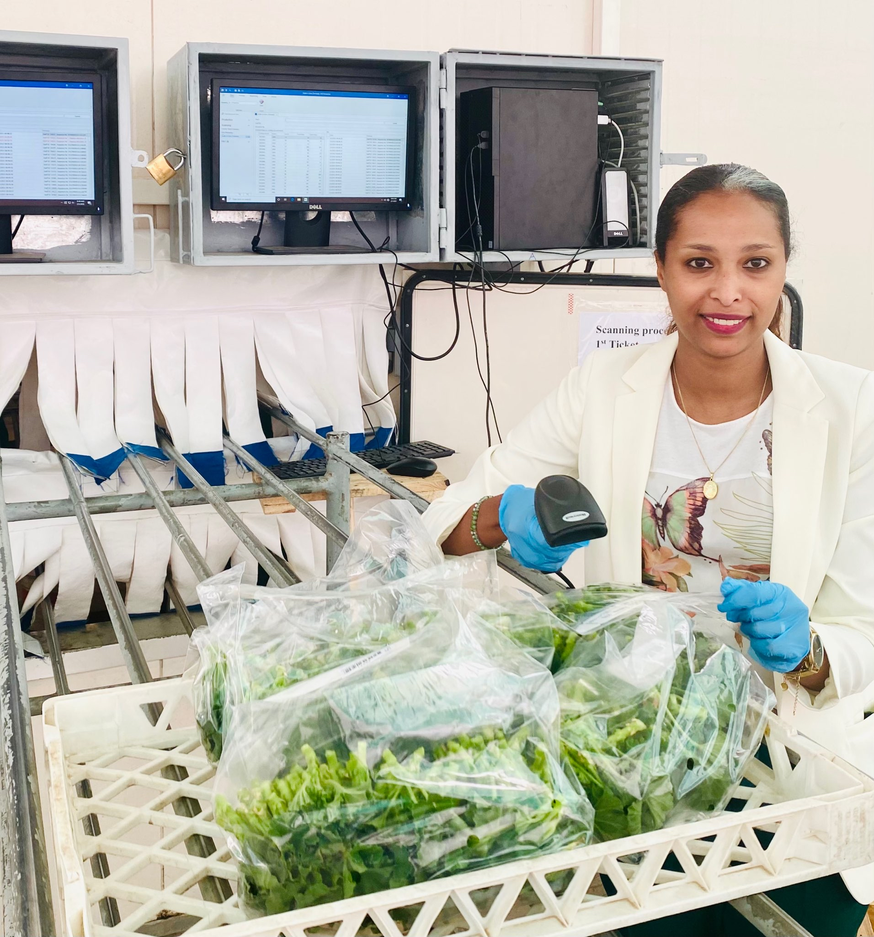
In Initiative #567 Consolidate scanning process we were moving the scanning process of collecting harvesting data from the greenhouse to the cooling entrance. Previously each harvesting group had one scanning operator who was in charge to scan each harvesting bag and each employee ID-Card during harvesting process.
With the implementation of the project, now each harvester posts an ID-Sticker on the bags and this sticker is scanned at the cooling entrance. With this procedure we were able to avoid the hiring of 37 scanning operators and we are no longer in need to maintain the very expensive greenhouse scanners anymore.
In total we are saving €50k per year and the team of Red Fox Ethiopia is very proud that we have reached L4 stage as the first initiative in the Offshore Supply Chain Workstream.


PURCHASING
Martijn van Maaren
Senior Purchaser
Group Purchasing is involved in several Flower Power projects. One of these projects is being executed together with the team of Quickplug in the Netherlands. The project focuses on optimizing the repetitive purchasing of molds that are crucial for the production of Quickplug.

For a production run of plugs, a batch of 130 solid plastic (HMPE) molds are being used on a conveyor belt. A unique substrate mixture is being pressed into these molds to form the plugs. Every design has its own batch of molds. Piles of molds can be found in the warehouse of Quickplug as you can imagine. Over the years, these molds were delivered by a local incumbent supplier, which was not their core business and turned out not to be the most competitive partner from a pricing perspective.

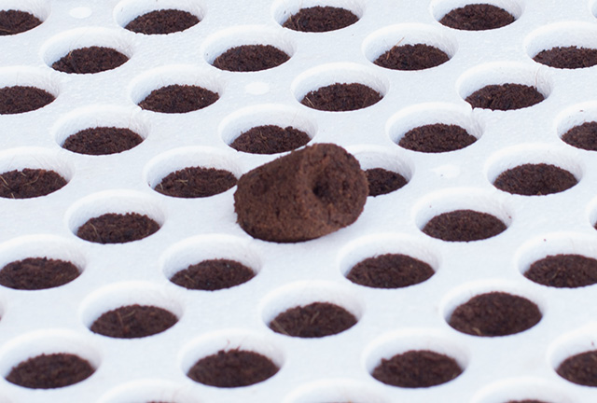
A potential cost saving was realized by the cooperation of Quick Plug with Group Purchasing to disclose potential new suppliers for these molds. Suppliers from other business units within the Dümmen Orange group were approached to check their possibilities for manufacturing of molds. One supplier from within the
DO group matched the requirements and their prototypes were successfully tested with their proposed equivalent cheaper material. These new molds did not affect the quality of the produced plugs at all.

By using the know-how of Group Purchasing department and the expertise of Quick Plug, a supplier in the group-network was matched with the specific requirements to provide the mold.

This collaboration leads to a cost reduction for the molds of more than 40% on average.

APP EMEA
Kim Fokke
Customer Operations Manager EMEA
During our ideation session last summer we defined 32 ideas with the full APP team! Now we have 15 projects live and kicking with a potential of 5.5 million EBITDA in 2023. One of these project is; Surcharge and stop cost drivers. This project aims to improve our margins by reducing our transportation costs

We focused on three areas with high transportation costs:
- Delivering sales outside Europe - add the correct transport costs on the invoice
Improvements: we are checking upfront the latest rates for each other, due to Covid all the airfreight prices are impacted. Unfortunately all prices have gone up!
The logistics team is working closely with CS to make sure the customer is informed about the actual costs and these will be charged accordingly. No more ‘assumptions’ on prices and a potential loss in margins.
- Transportation of small orders within APP EMEA – Transport Fee
Improvements: last year we rolled-out a small order Fee in Germany – the transport costs for the first few boxes or first CC trolley with RC are always the most expensive. Now we’re sharing the ‘pain’ of these costs with the customer. Our customer is still able to buy smaller amounts but we ask for a compensation in transport costs. In the project we copied this idea to France for current Pelargonium season and making plans for summer season.
- Flights to rooting stations in low season – combination on weeks
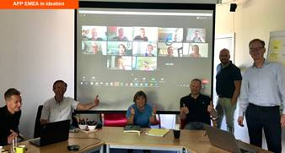
Improvements: the logistics and back-office teams are proactively checking the shipping volumes from our farms to our rooting stations in Spain and Italy. In case we have 2 small delivery weeks we try to combine this in 1 shipment without impacting the delivery date to our customers. Thanks to our rooting teams and their flexibility we’re hoping to save at least 20 flights!
A big thank you to the full team to make the first L4 Submissions and official L4 status possible!

If you have ideas on which topics we need to include? Please let us know at Flowerpower@dummenorange.com

Are you interested in learning more about FlowerPower and do you have access to a computer? Well, then we invite you to visit our intranet page https://intranet.dummenorange.com/site/en/flowerpower

