Let’s Celebrate!
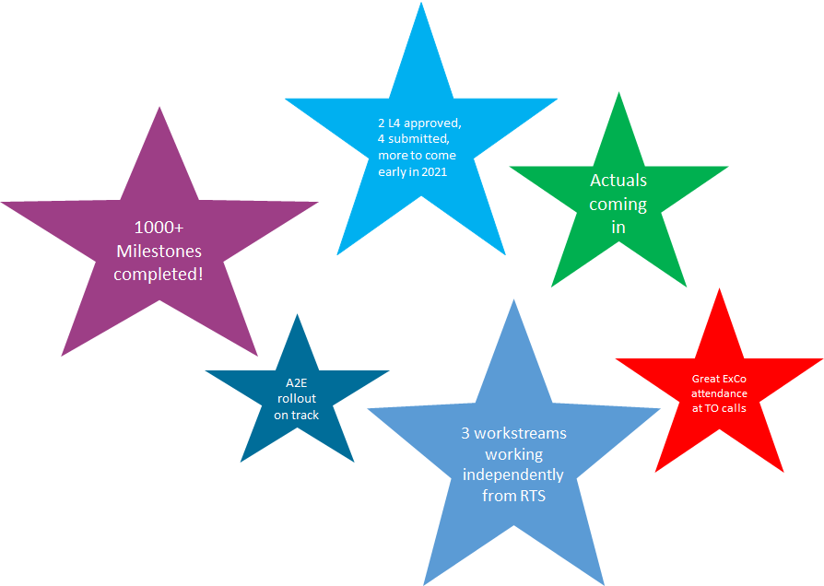

Looking back at 2020, we are proud to see the first results of the work that has been put into our FlowerPower projects!

A group of over 160 colleagues around the globe have been and will be working hard on making this project a successful. The success of these collective projects under the umbrella of FlowerPower will help us to become a solid and successful company that is well positioned for the future.

FlowerPower stories from around the world


SOGO - Taiwan
In SOGO Taiwan we are working on a Nursery waste reduction project. Our goal is to reduce waste to 600-800K plants in 2023 vs. 1.5M in 2020 by :
- 25-50% reduction of nursery waste due to disease
- 25-50% reduction of nursery waste due to quality of TC plants (size, roots)
- 25-50% reduction of nursery waste due to greenhouse management
Ton Witmer
Operations Manager SOGO
Let’s zoom in on the reduction of nursery waste due to quality of TC plants.
Losses of TC plants at deflasking and in the first few months after planting are high due to small plant size and/or lack of roots. In order to reduce these losses, the SOGO lab is working on two large improvement opportunities:
- Improvement of rooting of TC plants by:

  - Use of LED light with different spectrum
  - Use of different rooting media
  - Adjustment of rooting cycle based on variety
- Improvement of TC plant size by:
  - Grading of plants for rooting phase
  - Adjustment of elongation cycle, if necessary ST2.2
  - Adjustment of rooting cycle based on variety

We realized that making these improvements stick in the organisation, we not only need to focus on describing the processes and tasks, but also ensure that our employees understand the importance and change their way of working. This is why we conducted a training course for all employees involved with the following objectives:
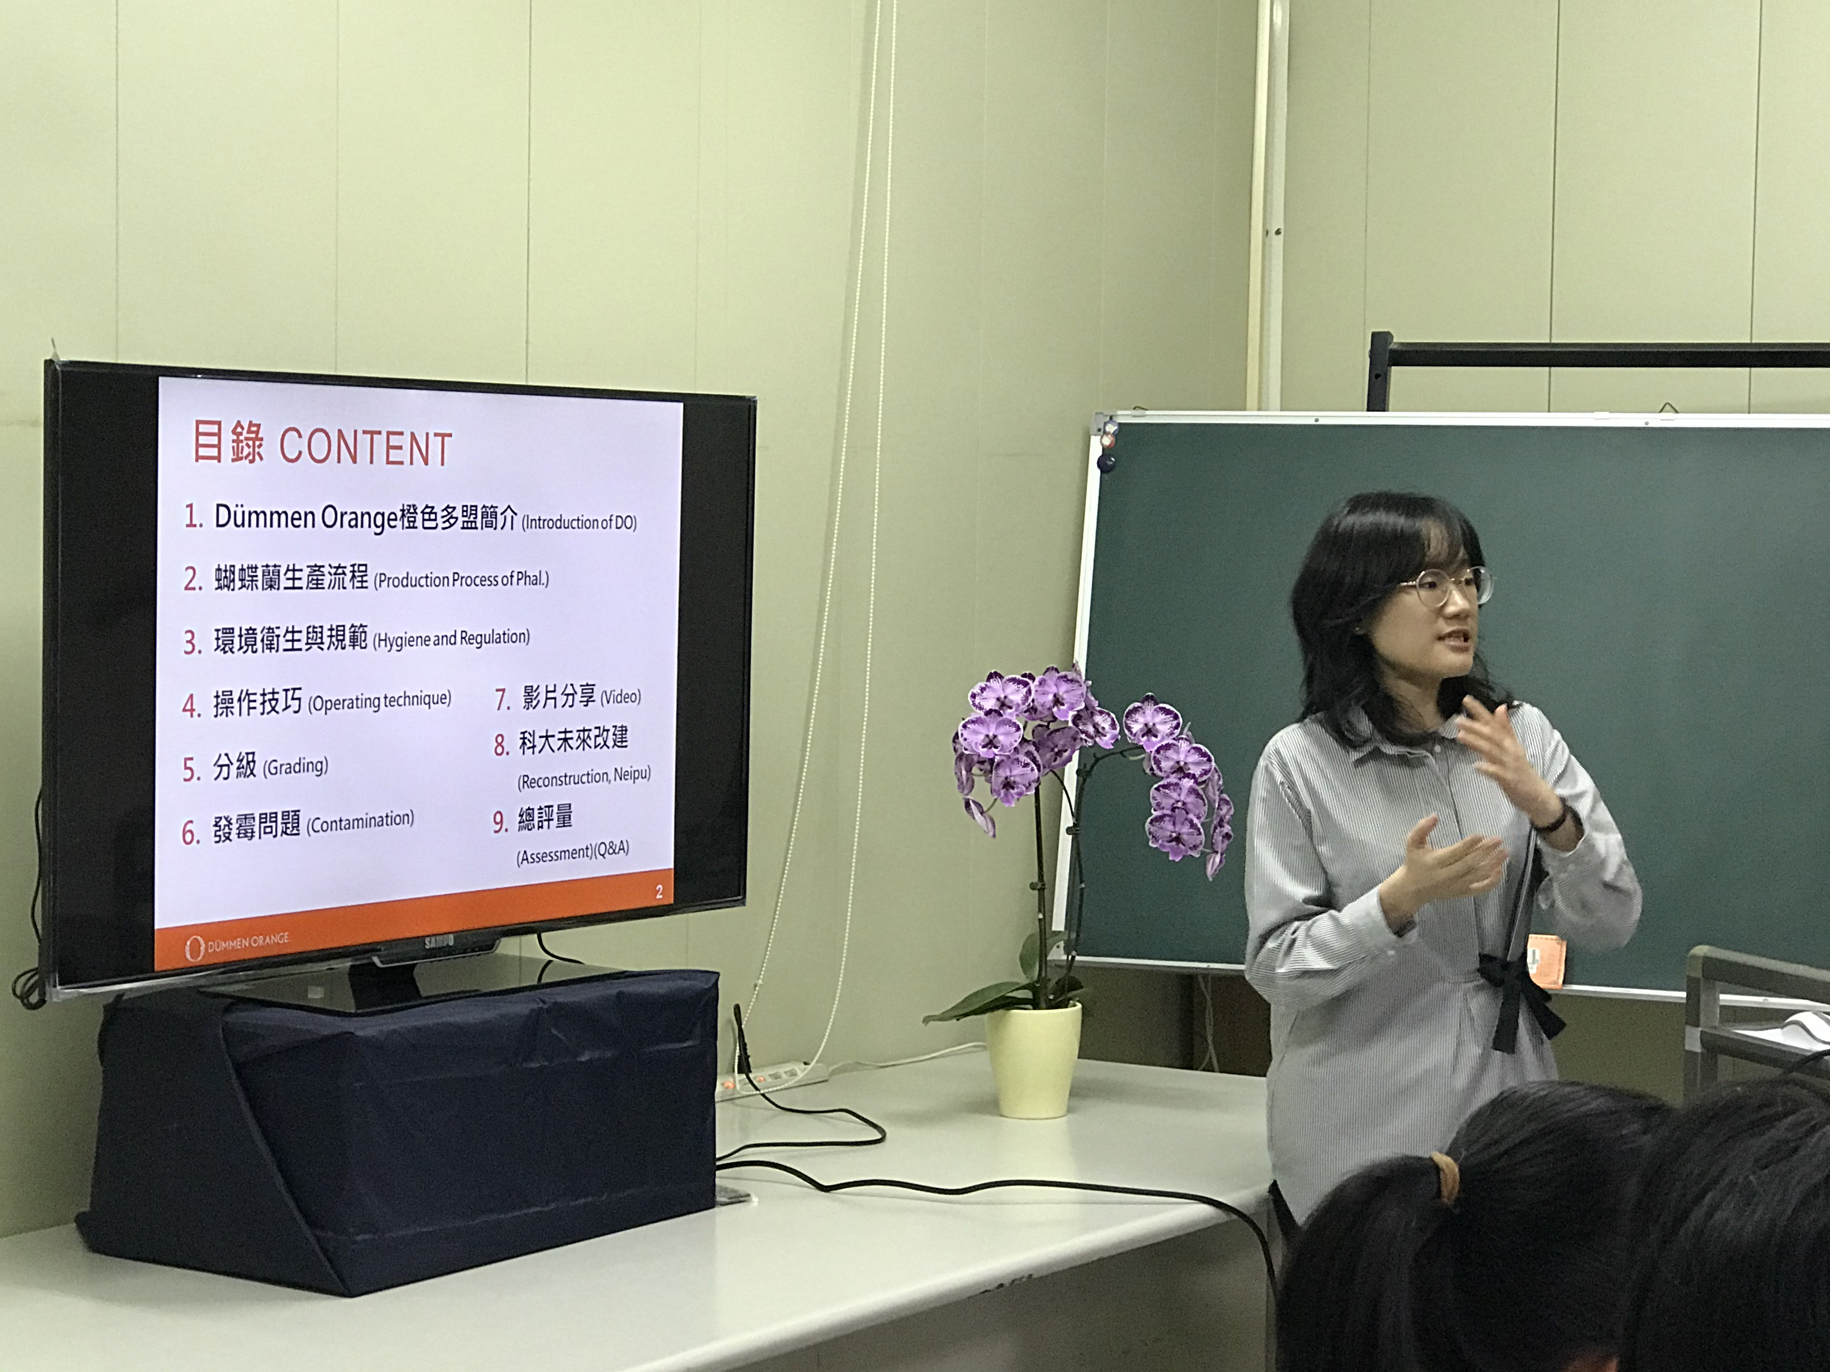
- Make our lab staff and operators more aware of the importance of proper hygiene and standard operating procedures to reduce the losses due to contamination in the lab
- To explain about the losses due to size in later stages (nursery) and emphasize the importance of good grading when putting plants in the rooting stage. To assure plants are big enough at deflasking they have to start the rooting phase with a minimum size, so proper grading is important.
- To explain about the planned restructuring of the Neipu lab in order to improve hygienic conditions and reduce the losses due to contamination.

We expect that after this training course our operators will pay more attention to proper grading of plants and to application of our Standard Operating Procedure, reducing losses by contamination and because of too small size at deflasking.


Cut Flowers
During the first ideation session with the full EMEA Cut Flower team, 12 projects were defined with a potential of 6 million EBITDA spread over a variety of crops. Two of the larger projects are the outsourcing of the rooting of cutmums in de Lier and the growth of our cutmums in Kenya. Both are nicely on track and will provide us with substantial cost savings and volume growth resulting in higher margins.
Reinoud Hagen
BU Head Cut Flowers
In Gerbera we defined a short term target with the introduction of 2 new varieties Dixon en Everton. We successfully did this with Colors of Nature.
In Rose we are evaluating to possibly change our Royalty model to a model that provides better revenu in the long term.
We have defined plans with regards to the market growth for cutmum and rose and are currently well on our way to execute this. Although it may be a bit early to say, we see that all lights turn green and we’re comfortable that we can achieve our targets. The introduction of new varieties like Red Tacazzi, Momentum, Snowstorm and Ilonka are the drivers for growth in our market share.
If we take stock after these first 6 months, we are proud that we achieved approx 30% of the targeted 6 million EBITDA growth. We anticipate to be at 40% in fiscal year 2021.
The biggest advance for all of us is that plans are being strictly executed, which was something we lacked in the past. Big compliments to everyone who is involved in these projects and deliver on top of their normal work.

Procurement
Within the Workstream of Procurement there is a project to reduce travel spend. Of course, with Covid-19 this appears to be an easy target to achieve. However, one of the achievements in this project was to implement one common tool for on-line videoconferencing.
The reasons for moving towards one global digital communication tool are these:
- The world around us is changing rapidly and the use of digital communication becomes increasingly part of our day-to-day way of working. It not only helps us to easily connect to our colleagues, customers, partners and suppliers, but also saves us time to travel.
Ellen Lakeman
CHRO
- Another reason why Dümmen Orange feels strongly about the use of digital communication tools is our corporate social responsibility. By reducing our travel movements (both by car and plane), we take responsibility for our planet and improve our carbon footprint.
- From an employee perspective it helps if we can present ourselves to our customers, partners and suppliers in a professional manner. With the global introduction of ZOOM in our company, there is no longer need to use private tools or Email addresses.

For the past 2 months we have been working with a small global project team (Benjamin, Maik, Jennifor, Shanna, Bart, Ron and Lysanne) on the roll-out of ZOOM. The team has had help of a larger global group of test-users to ensure that we addressed all potential issues ahead of time. The team has also done an excellent job in preparing training materials to make is easy for our users to get started.
In parallel to this, Seth has been running a similar project for the roll-out of ZOOM phone licenses specific to McHutchison. Due to great teamwork we were able to align both efforts. As a result of we have successfully rolled out 500 Zoom licenses and 100 Zoom phone licenses to users around the globe on December 4th.
Our initial focus was on laptop users and McHutchison phone users. Going forward, we have started phase 2 which is about connecting workstation users and conference rooms. We anticipate to have this phase completed by mid Q1 2021.

If you have ideas on which topics we need to include? Please let us know at Flowerpower@dummenorange.com

Are you interested in learning more about FlowerPower and do you have access to a computer? Well, then we invite you to visit our intranet page https://intranet.dummenorange.com/site/en/flowerpower

