OHI Update

We like to introduce you to a new program: Ability to Execute (A2E). This is a program to build capabilities within our organisation. It also will help us to speak a common language and have a common approach towards execution of activities. It is very pragmatic and easy to use.

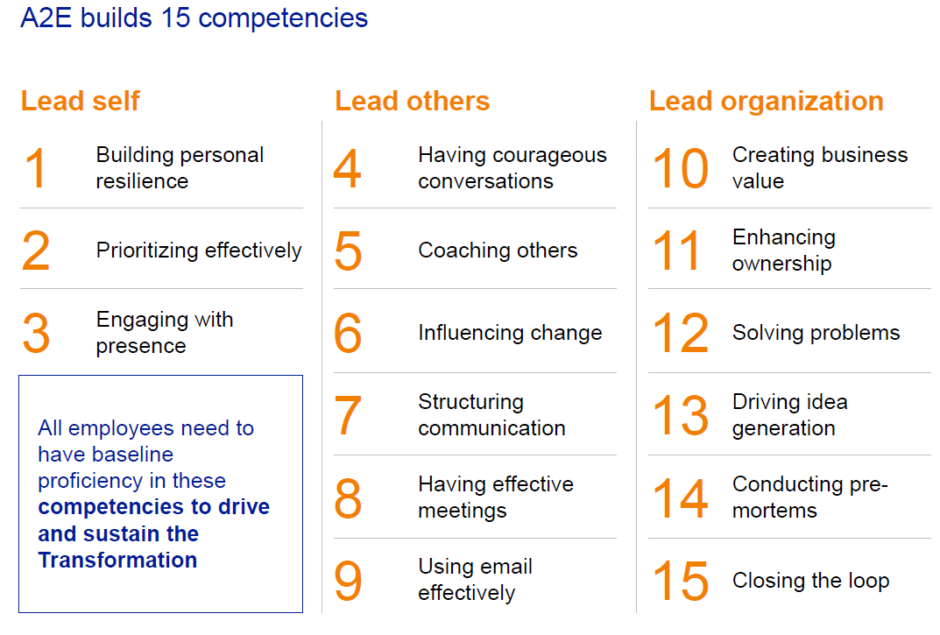
The way we describe the A2E program is like a box of chocolats: there are 15 modules in the program and there is always a couple that you really like!

During October we have trained a group of 30 employees (our early adopters). From this group 12 employees have signed up to become a facilitator and will roll-out this program within their Business Unit, Region or Function. At this point in time we are working on the roll-out plans per BU/Region/Function and aim to start a tailored training program during the first quarter of 2021.

Check out the FlowerPower Intranet page to find out who the facilitator in your area is!

FlowerPower stories from around the world

LATAM
Let me take a moment to share and explain my two FlowerPower projects with you:
Organising the import of Zantedeschia tubers: We have a good market in Brazil, but due to the exchange rate it is difficult to make any money for the grower. So we are looking how to reduce the import cost. We are investigating to grow smaller tubers here and the year after sell them on the "pot market". Also we are testing new varieties. In the next two months we have the first shipment.
Michel de Graaff
Area Manager Brasil
3 new introductions of pot plants: Dümmen Orange has a wide range of products, but we can not import everything into Brasil. So we are looking from which country we can ship into Brasil or do a whole new import project with a real new pot plant for Brazil. With the COVID pandemic a lot of growers are looking for something new, because the pot plant market is going really well. Even with the "strange import rules" of Brazil, we have a lot of possibilities.
The reason for these project is the challenge to succeed. It is not easy in Brasil with all the bureaucratic rules and import restrictions. That's why not many companies are doing it. But if you want, there is a way to do this by the rules and have success on the Brazilian market!
Our objective is to have a bigger share on the Brazilian market. Our industry is growing here and more people can work in the flower business and even start their own company. In Brazil I´m the only DO employee at this moment, when we are growing here, maybe I can have a college!
Our customers benefit as they are looking for exclusivity products and we can offer them. Also it is possible to charge a good royalty rate so this will be good for the grower (exclusive product on the market) and for Dümmen Orange.


Rooting Rheinberg

On our location in Rheinberg, one of the activities is the rooting of Annuals, Perennials and Pot Plants for the EMEA sales region. We root around 120 million of cuttings per year on various locations in Germany and the Netherlands, and we deliver these rooted cuttings from our distribution location in Kevelaer to all our customers.
Heleen Sonneveld
Operations Manager Brasil
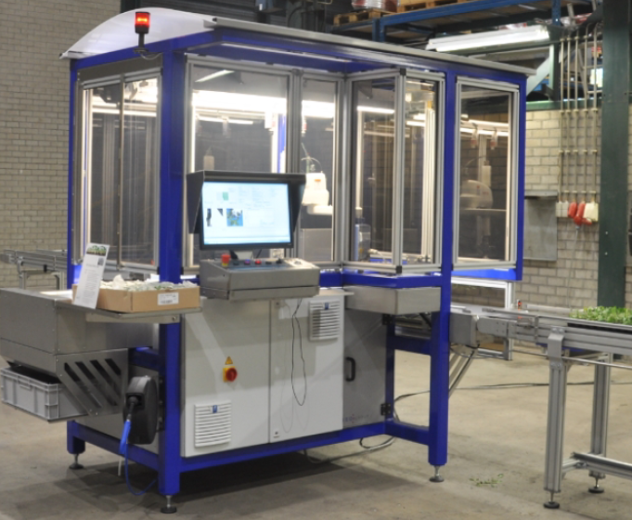
The Operations Team and the Cultivation Team are responsible for rooting and delivering excellent quality of plants, in full and on time.
For Flower Power we have a couple of very interesting projects lined up:
- 468 Project RoboCrop: the installation of 6 sticking robots on location Rheinberg, with the goal to save substantially on casual labor in order to keep cost prices competitive. The first robot has been delivered in week 47 and we have started to work with it in week 48!
- 491 Optimize CC Trolley returns: a project to improve timely returns of transportation materials from the customer to our distribution location
- 490 Footprint rooting: here we will answer the question what should rooting and distribution look like in the coming years, and how can we stay competitive
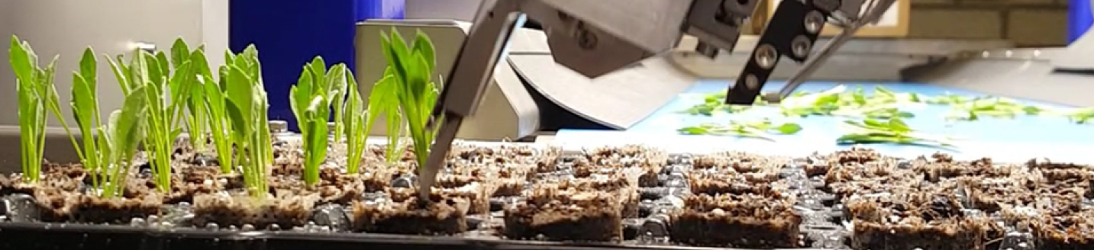
- 4332 Improve Transportation: some crops are inefficient in loading and trolley filling rate to the customer. We are looking into ways to improve this, by using a different tray for growing and for delivery.
So a lot of exciting things going on in Rheinberg, with the help of our Rheinberg Team!

If you have ideas on which topics we need to include? Please let us know at Flowerpower@dummenorange.com
Are you interested in learning more about FlowerPower and do you have access to a computer? Well, then we invite you to visit our intranet page https://intranet.dummenorange.com/site/en/flowerpower

