OHI Update

During the summer period we have conducted an Organisational Health survey (OHI) to measure the wellbeing of our organisation. Three Group actions were identified from this:
- Provide a clear Shared Vision
- Establish a result oriented culture
- Roll out capability program for enhancing execution power of our company

On the progress of the Group actions, we will be informing you during the upcoming communication sessions and we will send out a separate Email.

Besides the Group actions, every department, region and BU has taken the responsibility to communicate the results for their team and create an action plan together with their teams.. We recently have followed up with each of the leaders and it is wonderful to see that there is great progress in the action plans on OHI.


17
80
Milestones


3
Group Priorities
Action Plans Generated

FlowerPower stories from around the world

Procurement
The set-up of our Procurement workstream is twofold;
- to support other projects that require negotiations and contracting with suppliers to achieve their goals and
- to initiate our own projects that focus on streamlining processes and improve the financial return for Dümmen Orange.
Vincent Ausems
Group Purchase Manager

In order to do so our project team consists of colleagues from all around the globe and from different departments. This approach enables us to easier share know-how and benefit from local, regional and global markets. At this moment the Procurement Workstream is involved in 35 projects.

One of the projects, led by Jose Antonio de la Puente from El Salvador, looks for opportunities to reduce cost through cross-location cooperation. This will be achieved through bundeling our efforts and leveraging our procurement power at regional level. More specific, volumes are combined in order to have a more interesting package for our suppliers. This will also lead to fewer suppliers and a more longer-term and important relationship with the remaining suppliers. This approach will also allow for a more strategic partnership with our suppliers which will benefit our customers as well. Our customers can rely on Dümmen Orange as a reliable partner for the delivery of high quality cuttings.


Retail
Retail management is about selling the final product to the grower before they even bought our cuttings. It provides security for our customer as they will only have to focus on growing their products.

We do this by combining the knowledge of Dümmen Orange, the growers and retail. It is about matching the right products and concepts also to secure QOTIF from beginning to end (sales to consumer).
Maik Epping
Retail Manager Western Europe
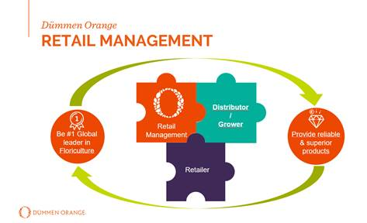
This is important because we see that the retailers are looking for tailor-made solutions to differentiate them from their competition.

By building and maintaining a good relationshop with decision makers in retail, we are closer to consumers in understanding their wishes and needs. This allows us to breed the right products on long term, and find the right products and concepts on short term.

This push - pull situation provides more opportunities to bring our products to growers and retail.

The benefit for our customers is that they get the right products for the right retailers while the retailer knows the demand of the consumer.

To summarize: It´s always good to be a bit different. Buyers need inspirations while products become more and more comparable . By involving everybody in the chain we make our products their products.

If you have ideas on which topics we need to include? Please let us know at Flowerpower@dummenorange.com
Are you interested in learning more about FlowerPower and do you have access to a computer? Well, then we invite you to visit our intranet page https://intranet.dummenorange.com/site/en/flowerpower

