So where are we now?
We are currently in the Implementation Phase

Last time we shared with you what FlowerPower is about and the work that has been leading up to the implementation phase. Going forward we like to provide you more insight on the actual projects that we are working on across the globe. We hope that this way you get a better understanding on why and what your colleagues are doing when they mention FlowerPower.

To give you an idea about the dimensions of FlowerPower:
140+
180+
300+




25
People Involved
Turned into projects
Ideas Generated
Country Locations

FlowerPower stories from around the world
North America


What can you tell us about your initiative?
One of my Projects is to develop and build a Dummen Orange “For You” packaging program to promote our new and existing commercial programs.

What is the reason or doing this?
Separate ourselves at retail with distinct packaging.
Rebecca Lusk
Retail Director, NA
What is the impact for the organization from a commercial and people perspective?
It will allow our sales team to interact with a new channel - Independent Garden Centers and their suppliers.
Our Sales always want something new to offer to their customers. It allows them the opportunity to use the containers as a vehicle to drive more Dummen Orange cutting sales. Also, it gives great pride when you can see your companies flowering material in a Dummen Orange branded container at retail.

What will be the benefit for our customers?
Merchandising our best in class, proven performing genetic in an simple, eloquent “For You” container will give consumers top performance and satisfaction in their garden.

Why doing it now?
Our goal for NA retail is to begin to focus on alternative channels outside of our value chain or box partners. Developing retail programs and solutions for Independent Garden Centers is the next step for expanding our retail opportunities. This new channel business will support transactional growth in volume and profitability within our industries retail commerce. Our goal is to continue to execute existing retail plan, such as the “For You” initiative by building more tailored, exclusively owned programs for all retail segments.

Africa
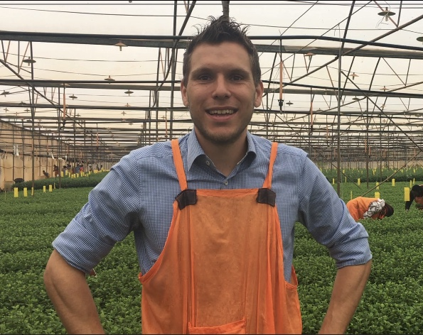
One of the projects I’m involved in is related to optimizing the safety buffers we have in the supply chain of our cuttings. Analysis has shown that we keep a lot of different safeties throughout our supply chains. Safeties give us possibilities to sell additional cuttings, or prevent shortages in case of bottlenecks in the supply chain, but it also results in surplus in the chain. Surplus we have created, produced, and shipped; costs are made but not sold in the end.
Bart Engels,
Regional Operatioal Manager
This initiative strives towards the optimal setup of the safeties in our supply chain. To adjust safeties which are double, too high or not used and thereby reducing costs, and to focus on the safeties which provide us the competitive advantage we need in the market like delivery reliability and quality. In other words, produce what we need!

Our industry is requesting a leaner supply chain, where our production and demand are closer aligned. By optimizing the safety buffers we will see a higher percentage of harvested/rooted cuttings for orders on our production and rooting facilities.

The safety buffers have been a focus point for a longer period in our organization, and after analyzing the entire supply chain and all crops we feel that we can get the optimal results out of it. Learn from the best in class and implement standards. Looking forward to working together to bring the efficiency to our supply chains.


APAC

What can you tell us about your initiative?
We have 10 Flower Power initiatives that I would group into three categories: 1) Enablers; 2) Growing in established footprint markets; 3) Entering and growing in under explored markets. All three categories are super exciting.
1) Enablers: is all about making sure the basics are right in our three country units (China + Taiwan, Japan, Rest of Asia). We need to secure basic elements to best support our customers and our commercial teams.
Nick Bennett
Commercial Director, China & Japan
2) Growing in established footprint markets: we have been present in Japan, Taiwan and China for a long time, we have great customers, great products. However there are things we can do better to outperform the market. We can capitalize on our brand and footprint and grow aggressively.
3) Entering and growing in under explored markets: the company acknowledges that we have for a long time under-serviced some of the fastest growing floriculture markets in the world along with developed markets. This category of initiatives is focused on ensuring that the company can make the most of these very large opportunities

What is the reason or doing this?
APAC has 52% of the world’s population (4.4billion people), 90% of the people entering into the middle class over the next 10 years will be from APAC and the value of retail floriculture is estimated to double to 100 billion euros within 5 years. APAC is a great opportunity for us and we have a compelling story to say that Dummen Orange should be the number 1 provider of genetics in the market if we invest, focus, prioritise and bring our passion for floriculture to APAC. We believe by doing so, we can help to significantly improve the overall business performance of Dummen Orange and grow sustainably.

What is the impact for the organization from a commercial and people perspective?
There are three key benefits:
1) We will expand the Dummen Orange brand globally
2) Connect more deeply with a broad customer base, understand new trends and customer needs to better inform our breeding decisions
3) Transform the company to be present in the largest floriculture market opportunity in the world

How will this impact the work of employees?
I already see a very positive impact on our team. We are really starting to see our contribution to Dummen Orange as significant. The hard graft of the team is being recognized and most importantly the efforts that can further be made and substantial to help Dummen Oranges global result. I see that the planning has really given us a path forward and I sense even great passion than ever before from the team to reach and execute relentlessly on our milestones.

What will be the benefit for our customers?
The benefit for our customer is increasing the intimacy of our relationship and building partnerships. We believe through this we can give our customers broader access to our portfolio, investing further in developing varieties focused on their needs, improving our communication and also providing tools, such as WeChat ‘mini programs’ to come up to speed with their expectations upon us. We have aligned with them that we can innovate together in business models and help to deliver more value along the value chain.

Why doing it now?
We are already late to enter APAC, but the window is still open and if we go now, we still have a great opportunity to take a thought and product leadership position in the strategic markets. The investment is manageable but the benefit to Dummen Orange and our customers is substantial. By acting now we can seize a great opportunity for Dummen Orange.

If you have ideas on which topics we need to include? Please let us know at Flowerpower@dummenorange.com
Are you interested in learning more about FlowerPower and do you have access to a computer? Well, then we invite you to visit our intranet page https://intranet.dummenorange.com/site/en/flowerpower

