Introduction FlowerPower

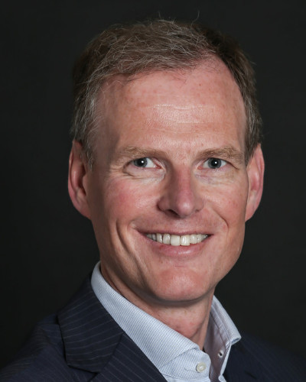
Let me introduce myself, my name is Johan van ‘t Hag, in my role responsible for Strategy and M&A, I am also the Chief Transformation Officer of Dümmen Orange’s FlowerPower project. FlowerPower is an allround effort driving both business performance (what) and organizational health (how) of our company. It is a companywide program to address our challenges and unlock our full potential.
In the last couple of months, we have been working hard on this project with a selected group of colleagues. The project is supported by the central Transformation Office. This team supports all colleagues participating in the project to make this change a long lasting success and facilitates and streamlines the numerous activities in this program.
In my role as the CTO of the program, I have been delighted to work closely with many creative, energetic and professional colleagues around the globe during the ideation and planning phase of the program. I’m sure we will be in touch with all of you in one way or another when we approach the implementation stage.
As all of you will be most likely impacted by the FlowerPower project in future, we like to keep you posted on what’s to come. This monthly newsletter and our intranet page are two examples of how we will keep you informed.
Stay tuned for more updates on the progress of Flowerpower!

Where are we now?
We are currently in the Planning Phase
150 projects are moving to L3
182 projects moved to L2
231 ideas moved to L1
We are here!
Bottom-Up Planning
Implementation
L2
L3
L4
L1
L5
L0
Track
Plan
Implement
Validate
Ideas
Realized
Raw idea
Idea with assigned owner and rough estimated impact
Project defined with an approved business case
Project with approved business, milestones and implementation plan
Project implemented
Impact realized
282 ideas produced at L0

Talk with Ellen Lakeman

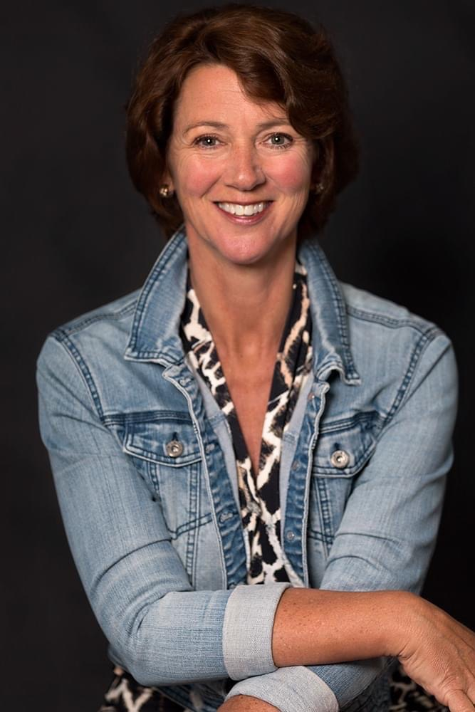
As the CHRO, global HR, I’m working closely with the FlowerPower project to ensure adequate follow-up is provided to the results of the Organizational Health Index (OHI) survey. FlowerPower consists of two major components: business performance (what) and organizational health (how).

Why is health important? Well, if you don’t change the way you do things, initiatives will not sustain overtime. In order to continuously improve and grow as an organization, we need to make sure that our initiatives are embedded in our day-to-day way of working. This means that with important projects like FlowerPower, we are not only looking at the business results, but also at the way that we achieve them and how we need to adjust our way of working to sustain them.

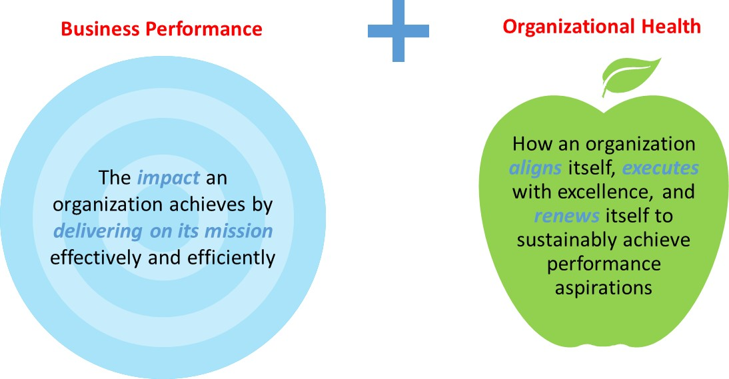
What can you expect from me?
Most important that we will start communicating the direction and shared vision of Dümmen Orange.
Secondly, we will be working to change our culture from effort to result orientation. Both priorities will require all of us to work on the way we do things, so our behaviors.

During the coming year you will hear more about how to do this.

What is next?

This newsletter will come out once every month and is intended for every Dümmen Orange employee worldwide. Going forward we will provide you with interviews of project leaders and the specific projects that they are working on. We like to ensure that you are aware of what is going on in the company, why we are doing this and what the benefits will be of these actions.

If you have ideas on which topics we need to include? Please let us know at Flowerpower@dummenorange.com
Are you interested in learning more about FlowerPower and do you have access to a computer? Well, then we invite you to visit our intranet page https://intranet.dummenorange.com/site/en/flowerpower

