Results OHI survey
During the second quarter of 2020 we launched DümmenOrange’s FlowerPower project to unlock our full potential. We are the number one flower breeder in the world with a strong position in a range of crops and with the backing of our investor we have been able to acquire a number of companies over the last few years and to invest heavily in research capacity. We also see the world around us changing like never before, with a market hit by Covid19 and a unique opportunity to renew and find common direction and purpose.
Imagine a future where…
- … our customers are our fans because we do what we say and we are who we say we are, whether that is the closest to the customer or the most innovative breeder
- … our employees are our fans, because of our entrepreneurial spirit, professionalism and raw innovation power.
And, because of these two factors, …
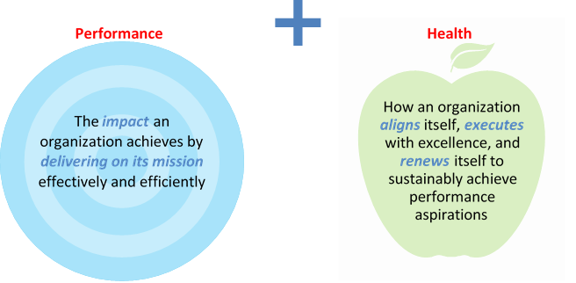
- … we grow faster than the market, at a competitive and sustainable profit level.
This is a huge change and we know that the make-or-break of transformation is not so much in defining the ‘what’ we do…this we know pretty well. It is in the ‘how we do things’: our mindsets and behaviors. In fact we know that 70% of transformations fail because of the ‘how’, because leaders don’t live and role model the change, or fail to mobilize/inspire the organization.

To make the ‘how-we-do-things-around-here’ more tangible and define concrete changes in the way we work and the way we lead, we have conducted the organizational health index survey. This survey measures the ‘health of an organization’ in terms of 3 dimensions:
- Alignment: in healthy organizations, everyone knows where we want to go, why this destinations is meaningful and they love being part of that journey and organization
- Execution: healthy organizations get things done. This means there is clear transparency on performance and targets, we have the capabilities and are motivated
- Renewal: healthy organizations are great in capturing external insights, e.g. customer or competitive insights, learn fast, and create and implement new ideas quickly
For us at DümmenOrange, Organizational health is not an optionality. We strongly believe it is a must to get right – for two reasons.
Firstly, health is a leading indicator: healthy organizations deliver 3x financial performance vs unhealthy organizations and are much more successful in transformation. Secondly, OHI measures outcomes (how healthy we are), but also the underlying practices (what we do). To make the parallel to people’s health: outcomes would be blood pressure, weight and heart rate; our practices would be how often we eat healthy food, how often we go to the gym and how often we have a good night of sleep to recover.
We are pleased that 43% of you have responded to the survey. This is a good result (although the more, the better) and we would like to thank those of you who have taken the time to complete the survey. Now we want to share back the outcomes and some of the key priorities we see.
Let’s start by saying that the overall outcome score for the company (67%), which means that we are in the better half of all companies in the database (~1800). It’s a good base to start from, but it is still a long way to get to the top 25%. If we dive deeper, the data shows that we have a good foundation in execution and renewal, but we also see the need to strengthen the sense of ‘alignment’. It is clear that the vision and strategy of the company is not sufficiently understood and our work environment could be more energizing. To make this more actionable: let’s look at the practices through the lenses of the three dimensions. High rankings (1-9) mean we collectively spend a lot of time and attention on these practices. Low rankings (29-36) mean we spend relatively little time there.
In terms of alignment: we have spent too little time sharing and engaging the organization on our vision and strategy. Execution-wise, we spend relatively a lot of time on setting targets and financial management, but much less in operational management and recognizing people for their contributions. It appears that we set strong targets, whether we deliver on them is relatively inconsequential. Finally on renewal: we score high on business partnerships, but less so on sharing knowledge and capturing external ideas.
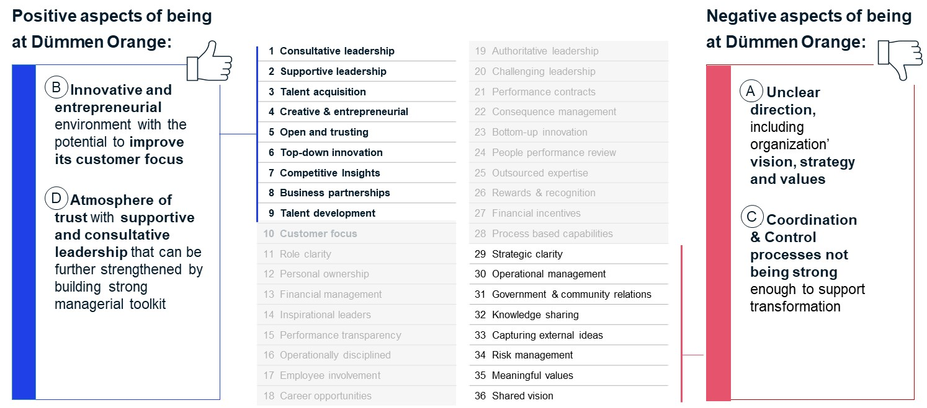In short: there is a good foundation, but we also see clear barriers in our ways of working to unlock our full potential and successfully transform towards a sustainable future as the market and innovation leader.
In our commitment to make DümmenOrange the most admired horticulture company and a great place to work, we have started to define our priorities as an ExCo:
- Direction: in the coming 2 months we will evaluate our vision, mission and shared values and realign this to the current state of the organization. Going forward we will also be working on how to operationalize our values into our day-to-day processes and actions. We will make sure that you will be included in this effort and the results will be clearly communicated.
- Coordination & Control is up to us all to improve on: we all need to celebrate successes but also acknowledge when targets are not met and how to recover from these setbacks. The success of our company has partly been accomplished through individual experts. However, the world we currently live in is disruptive and the pace of change is so high that we no longer can rely on individuals. We need to team up, share knowledge and all of us need to become active players on the road to success.
- Operational management: as Health is not a top-down activity, but something that is created by all of us, we have agreed with the BU- and other functional leaders to share the results of their departments with their teams. The team members will collectively define specific actions for the team to improve the results.

To emphasize this will not be a side activity, as organizational health / culture is at the heart of any organization and a make-or-break for our success. There is no business transformation without personal transformation, and as leaders we need to lead the way. The change starts with us.
It is our ambition to be a high-performing company and to make DümmenOrange the most admired horticulture company and the employer of choice. We therefore need to learn as an organization and as individuals and we invite you to join us on this journey.

Hugo Noordhoek Hegt

